Email: john.diamond@gmail.com

I welcome the publication of the preferred route for Metrolink and look forward to the submission to ABP for a Railway Order as soon as possible. In particular, the relocation of the excavation depot to an area close to the M50 is to be welcomed, with the disruption to Na Fianna and nearby schools minimised.
North of Airport: I support the use of a cutting, rather than an elevated railway. However, the Metrolink tracks will cut across the planned greenway route along the Broad Meadow River (Route FG2). A way for pedestrians or cyclists to get from Swords to the Estuary Metrolink station should be provided.
Airport: The project team should work with the DAA to provide elevated and covered travelators between the station and the Terminii.
Dardistown: I support the relocation of the depot to this area. The site indicated in the EPR at Estuary for use of a depot may be better used for housing in the future.
Northwood: I support the station design, providing easy access to the station from both sides of the Ballymun Road. It should also function as a pedestrian underpass of the busy Ballymun Road.
The Design Development Report mentions "accessibility to Gulliver’s Retail Park from the Northwood Station". Of much greater importance is the access for residents of Northwood, and for those who work in the various office developments in the development. Gullivers is a poor use of land adjacent to a metro station (Retail Warehouses). Cosgraves should be encouraged to redevelop the site to provide high density residential units and/or large scale office developments, either of which is a more appropriate use of land adjacent to a metro station.
With respect to the land between the Old Ballymun Road and the R108 I note that Bartra developments have said "We will need to work closely with TII to allow development to progress at the earliest opportunity and TII has indicated a willingness to do this." They intend to build "100 build-to-rent apartments, 250 beds in a "shared living" environment and 100 social houses. " I do not believe this mix of housing types is optimal. The housing development should not be solely social housing, but should be mixed (private/affordable/social). The shared accommodation should be reduced from 250 beds, with an apartment development available for purchase by private buyers. TII should encourage Bartra to reconsider their proposals.
With respect to the bridge over the M50, TII should work with Fingal County Council to use the same structure to provide a pedestrian and cycling overpass over the M50. Under Objective MT15 of the Fingal Development Plan 2017-2023, it is an objective to 'Investigate and avail of the opportunities provided by new Metro North and any other public transport infrastructure to provide new cycle and pedestrian links including crossings of the M50 which currently represents a major barrier to active transport modes.' Also easy access to the proposed Santry River Greenway should be provided, with bicycle parking facilities being an integral part of the station design. This would help increase the catchment area of the station. . Dublin City Council has adopted Objective MT09 as part of the Dublin City Development Plan 2016-2022:
"...to bring forward planning and design of the Santry River Greenway, incorporating strongly integrative social and community development initiatives."
Fingal County Council is supportive of this objective. This Greenway should increase the catchment area of this station, and adequate facilities for cyclists to secure their bicycles should be provided (this should be the case for all stations, and should not be considered just as an afterthought).
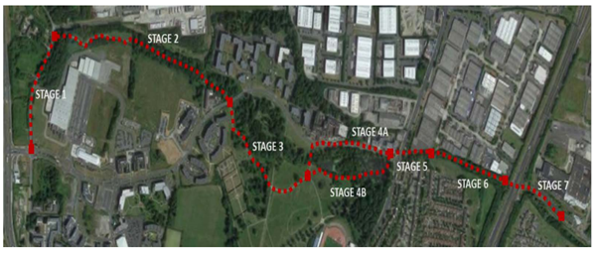
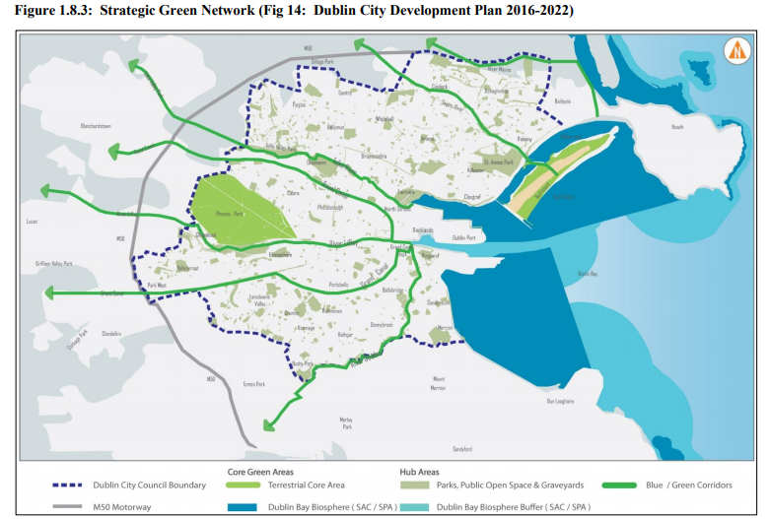

Excavation Depot: I expect that this should not unduly delay the provision of new facilities for Ballymun Kickhams, close to where their members live.
Ballymun: I am supportive of the location for this station, but would like to see the redevelopment of the old shopping center proceed as soon as possible.
Collins Avenue: Local residents are concerned at the location of the proposed station. Their suggestion of relocating the station to the north west of Albert College Park should be re-examined, with the results published prior to applying for a Railway Order.
Ventilation shaft at Albert College Park: The details of the proposed shaft were released just two days before the end of the consultation period. Submissions regarding this shaft should be accepted after the current closing date. This will allow affected parties to properly consider these details.
Glasnevin Station: I support the integration with the heavy railway lines at this location. I think this station should be named "Cross Guns Station". It is more specific with respect to where it is located, it is easy to remember, and it is related to the function of this station: The metro will cross (below) the railway lines. Also, the Royal Canal Greenway should be maintained during construction of this station, if at all possible.
Green Line Upgrade: There were a number of options given in the documentation for the EPR that appeared to be less disruptive on Luas operations when tying in Metrolink to the Green Line than the option discussed in "Constructability Report - Green Line Closure. It is disappointing that there is no discussion of these options except to say "If the portal is moved ‘off-line’, then the Green Line does not necessarily require closure for the full duration of the portal works. A closure is still required to connect the new and existing alignments with potentially a significant reduction in duration depending on the precise location. However, a preliminary examination of possible sites has revealed no clear and obvious locations in which an off-line portal could be placed without significant environmental impact." The results of these examinations should be made public.
I understand that it may be less risky to integrate the Green Line when Metrolink has commenced operations. However, to facilitate those who need to change to and from Metrolink a better station design at Charlemont will be required than that indicated by artist's impression given on the web site. The tunnel should continue on past Charlemont to minimise disturbance to Metrolink when any tie in works to the Green Line, or any future alternative metro route, takes place.

I note that the Dunville Avenue crossing will have to close to vehicular traffic as Luas frequency increases. I would support the construction of a bridge at the junction of St. Raphaela's Rd to facilitate increasing the frequency of Green Line trams.
Station Design: As island platforms will not be used, stations should be designed to a similar pattern i.e. regular users should be able to navigate to the required platform in any station without making major way-faring decisions. Related to this, ease of use by people with disabilities should be the forefront of station design.
Automatic Train Operation: I support the decision that Metrolink should use ATO from service commencement. It facilitates more frequent services, and a more flexible response to service demand.
Integration with Public Transport Modes: Stations should be designed for easy transfer with local bus services, and particularly with orbital routes (as proposed by the Bus Connects Network Redesign. This may require some changes to orbital routes when Metrolink opens, eg “O” route changed to connect with Mater Hospital Station.

