Santry
08/May/2018

Submission
On
Metrolink

A Chara,
I welcome the opportunity to make a submission regarding the emerging preferred route for Metrolink. I have a number of observations to make regarding the stops at Northwood, Mobhi Road, and the interchange station at Glasnevin. I also have some points to make regarding the possible closure of the Dunville Avenue junction in Ranelagh.
JD

Northwood Stop
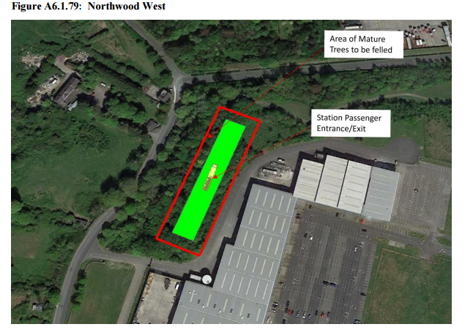
I am supportive of the proposed location of the Northwood Stop. It would be easily accessible from the residential and office developments in Northwood. It is also close to the route of the proposed Santry River Greenway, and access should be provided to and from it. Dublin City Council has adopted Objective MT09 as part of the Dublin City Development Plan 2016-2022:
"...to bring forward planning and design of the Santry River Greenway, incorporating strongly integrative social and community development initiatives."
Fingal County Council is supportive of this objective. This Greenway should increase the catchment area of this station, and adequate facilities for cyclists to secure their bicycles should be provided (this should be the case for all stations, and should not be considered just as an afterthought).
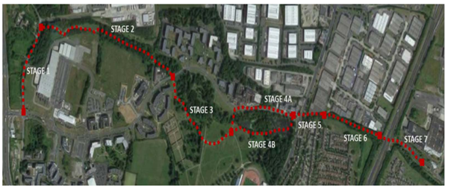
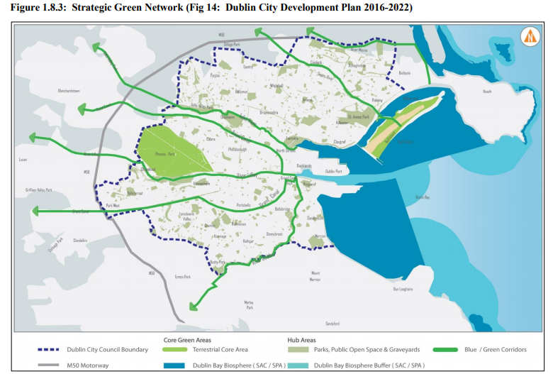

The option presented in the consultation document at the “Northwood Central” location is no longer feasible as there is a large housing development under construction at that site. However the land slightly to the west is still undeveloped and could possibly be used, if necessary.
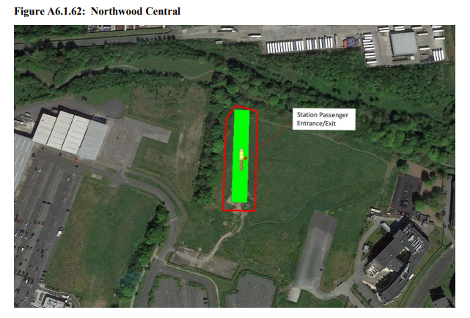

Also, the Northwood Station location in “Alternative Option B” is no longer possible because of a recent housing development. From conversations with engineers at the public consultation, if Option B is chosen a site in the vicinity of Northwood would be used as a launch site for the boring machines (and there would not be a launch site on Mobhi Road). The depot would be at Dardistown rather than at the northern end of the metro line, and would carry less environmental risk and would be more flexible operationally. I note that An Bord Pleanala previously asked for a revised application for Metro North using Dardistown as a depot, rather than a site at the end of the line.

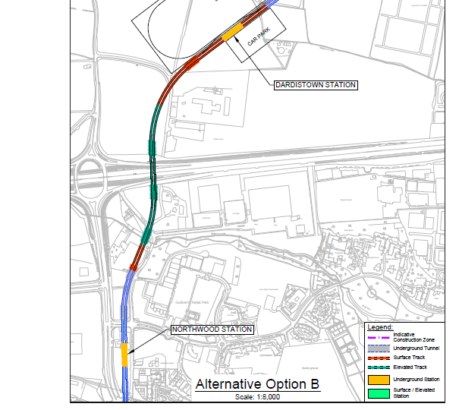
Consideration should be given to moving this station slightly east of the Old Ballymun Road, and perhaps to the north of Northwood Avenue, within the Northwood Estate, if “Alternative Option B” is chosen. Also, it may be better to site the TBM launch site to north of the M50, if technically feasible, as this would cause less disruption to residents and the Tesco warehouse facility, and may facilitate a greater range of location options for the Northwood station .
On a more general note, Tesco’s warehouse facilities and Gulliver’s Retail Park are both particularly poor use of land close to a metro stop, and hopefully will be redeveloped for residential /office use in the future. Route and station location selection around Northwood should not be overly determined by the location of these two facilities.

Griffith Park West (Na Fianna)
The proposal to site the TBM launch site at this site is unacceptable and, frankly, politically naive. It would cause too much disruption to schools and sporting facilities on the site. Also Mobhi Road is not suitable for a high level of construction traffic. The TBMs should be launched at Albert College Park (as per the existing Railway Order for “original” Metro North), or at a site in the vicinity of Northwood.
The construction of the station at the Home Farm pitch should be possible, if sufficient mitigation measures are taken. If it is not possible to proceed with this location (the project team have burned a lot of bridges here), the station location chosen should allow Metrolink to continue to the proposed interchange station at Glasnevin, in preference to having a station at Drumcondra. A station on or near Griffith Avenue would integrate well with an orbital bus route that may be launched as part of the Bus Connects project.
Whitworth
Whitworth is preferable to Drumcondra as a station location. It is more straightforward to build a station connecting Metrolink with the existing heavy rail (and future Dart) lines at Whitworth. It would also be a more “user friendly” interchange station, and in the absence of Dart Underground, a very important one. A comment has been made that the extra walk in Drumcondra would do people good. Unfortunately human nature being what it is, it would probably just encourage people to use their cars instead.
Ranelagh
The Green Line is to be upgraded to Metro South as part of the Greater Dublin Area Transport Strategy 2016-2035 and is included in the National Development Plan. It makes sense that it is included as part of this project.
The options for lifts and foot bridges over the line are not acceptable. Underpasses or bridges that cater for both pedestrians and cyclists should be provided at Dunville Avenue, and other locations, at a minimum. The permeability through the tram lines should be maintained as much as is possible. Decisions made prior to the construction of the Luas Green line are causing these issues, and are unfortunate.
Vehicle Type
If the issues with the Ranelagh section of the line can be resolved satisfactorily, then 60 meter automatic vehicles should be used. These are the most operationally flexible (eg they can respond to demand variations quickly) and will scale well into the future by either increasing the frequency to 90 second intervals, or by increasing the tram length.

